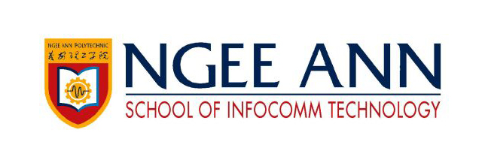

**Fundamentals for IT Professionals II**

Year 2 (2020/21), Semester 3

**SCHOOL OF INFOCOMM TECHNOLOGY**

Diploma in Cybersecurity & Digital Forensics

Diploma in Information Technology

**Assignment 2**

**Industry Engagement**

**Duration:** Weeks 12 - 15

**Weightage:** 20%

**Individual/Team/Both:** Individual

**Deadline:** Report

Softcopy (submit to MeL)

**31 Jul 2020, 9:00am (Friday)**

|  |  |
| --- | --- |
| **Student ID** | **S10189161D** |
| **Name** | **Tan Jia Shun** |
| **Module Group** | **P07** |
| **Grade** |  |

Contents

Participated Industry online Talks / Webinars 3

Reflection 3

Cisco Connect ASEAN 2020 3

Apple WWDC 2020 4

# Participated Industry online Talks / Webinars

1. Cisco Connect ASEAN 2020

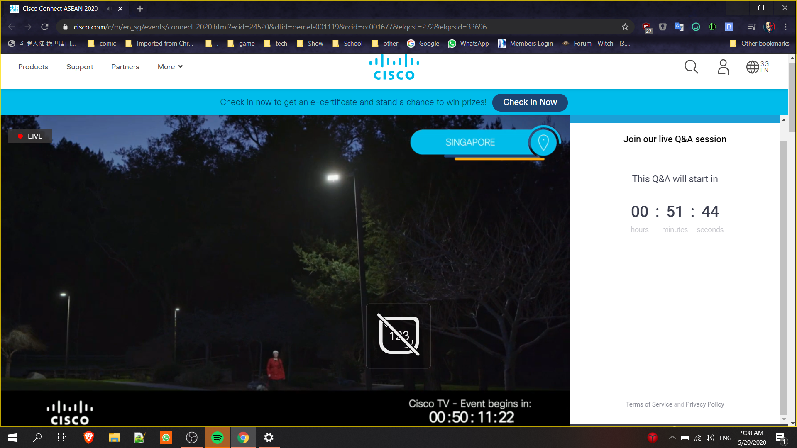

1. Apple WWDC 2020

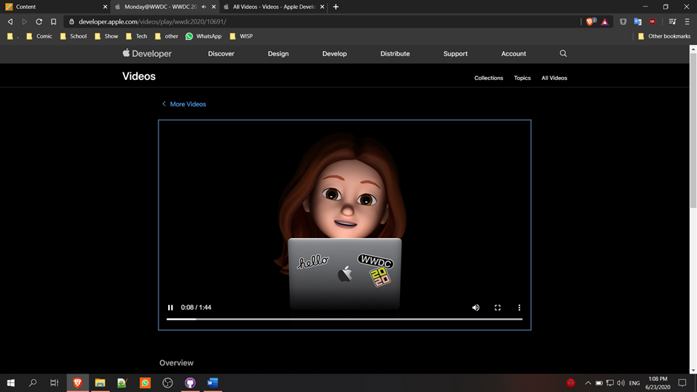

# Reflection

## Cisco Connect ASEAN 2020

Cisco is known as the one of the top IT and networking company worldwide. As a CSF student, where we learn about networking and security, at the same time when during internship in ITE, I see many companies is using Cisco router, I feel this webinar is needed for me.

Cisco Connect ASEAN 2020 Singapore is a webinar hosted to deliver education and inspiration talks to technology innovators worldwide. The webinar is done through a half talks and half pre-recorded video manner where they share their latest and greatest product and solution like their WebEx, a video meeting service, and many different new online security features to fight online attack with demo. They also talk about climax change and the COVID-19 pandemic, things they did or change to overcome those problem, and services they bring out to help their customer.

After going through the webinar, I feel it is very impactful. I better understand how networking work in the businesses, from the network structure to tools that is used to maintain the structure that is not learned in class.

## Apple WWDC 2020

WWDC is hosted by Apple yearly to showcase their new software and technologies. Apple, one of the top hardware and software, as a CSF student, I feel it is important to know the latest and newest innovation, so we can better plan for the IT industry. It is a 5 days online event where they talk about IOS 14, Apple silicon chips and many plans their have. The event is done through many 10 to 40 minutes short video. I feel this talk is relevancy to my course as when there is new technology, there will be new unknown explicit which we CSF student will need to find and fixed, and apple is known to make the most secure mobile phone, we can also learn new technology. They impacted my future goals as they talk about Apple's Security Research Device program, which may change my plan to force on apple security as we have more right when doing security research.